Analyt irn

All scenes Drag anal clrop data here to filter all scenes. || This scene Drag ancl drop data her



Travel Aggregator Analysis Story Board







Revenue according to Day of the Week

* Day of ftse week Thursday has the highest totat INR Amount
* from cfty Gurgaon kaa the highest totat INR Amount due
* INR Arruusnt ie unusually high

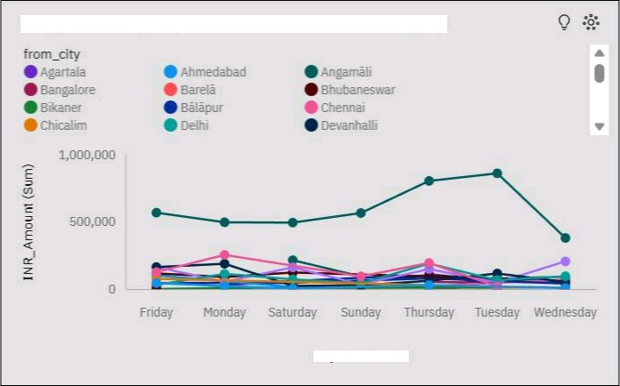

INR Amount by Day of the week colored by from city

Day of the week

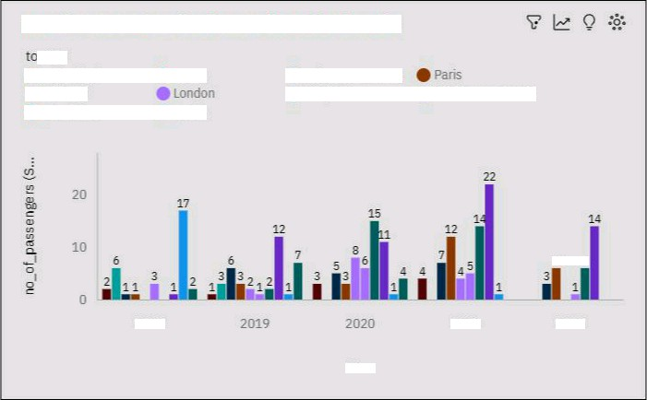

no_of pansen pre' by Year cdléréd by t.a c"rty

@i MurnâaJ

*@ ffi.*umicino

2018

2021

2022



no_of_passengers by Year cotored by ta_city

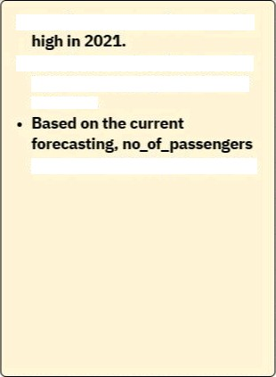

* s

ft

iura suaMy



INR_Amount by Day of the week

* Day of the week Thursday has





* Saturday haa a INR Amount of

akz ost ZZ7 thoueazuf for



sum of INR Amount is over 9.9

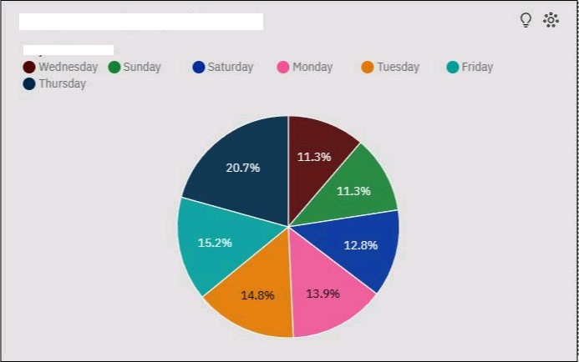

INR Amount by Day of the week

Day ofII+e week